# Instructions for setting up and exploring the operation of a single VM version of Kafka

The AWS cloud offers a managed version of Kafka but it is complex to configure and potentially expensive to run. Instead we will use a well-supported open source version of Kafka and install and manage it ourselves on a single virtual machine.

Note, for those of you who might want to include Kafka in a big data processing pipeline, in the future, you might try to install it onto an EMR/Hadoop master node, following the instructions below, but for the following assignment, we will use a separate virtual machine.

These instructions are divided into five sections. In the first we will set up an AWS EC2 instance (virtual machine). In the second section we will configure the virtual machine with the software and properties necessary to execute Kafka. In the third section we will learn how to start up Kafka and then, in the fourth section explore some of its capabilities. Finally, in the fifth section we describe how to stop, start or terminate your EC2 instance.

## Section 1: Instructions for setting up an EC2 instance (virtual machine)

1. Select “Services” on the AWS console. Then select “EC2”



1. Launch a new EC2 instance by clicking on “Launch Instance”



1. Select the Ubuntu 18.04 Amazon Machine Image (AMI)



Select an instance (VM) type of m4.xlarge (or if for some reason this is not available to you, try m4.large):

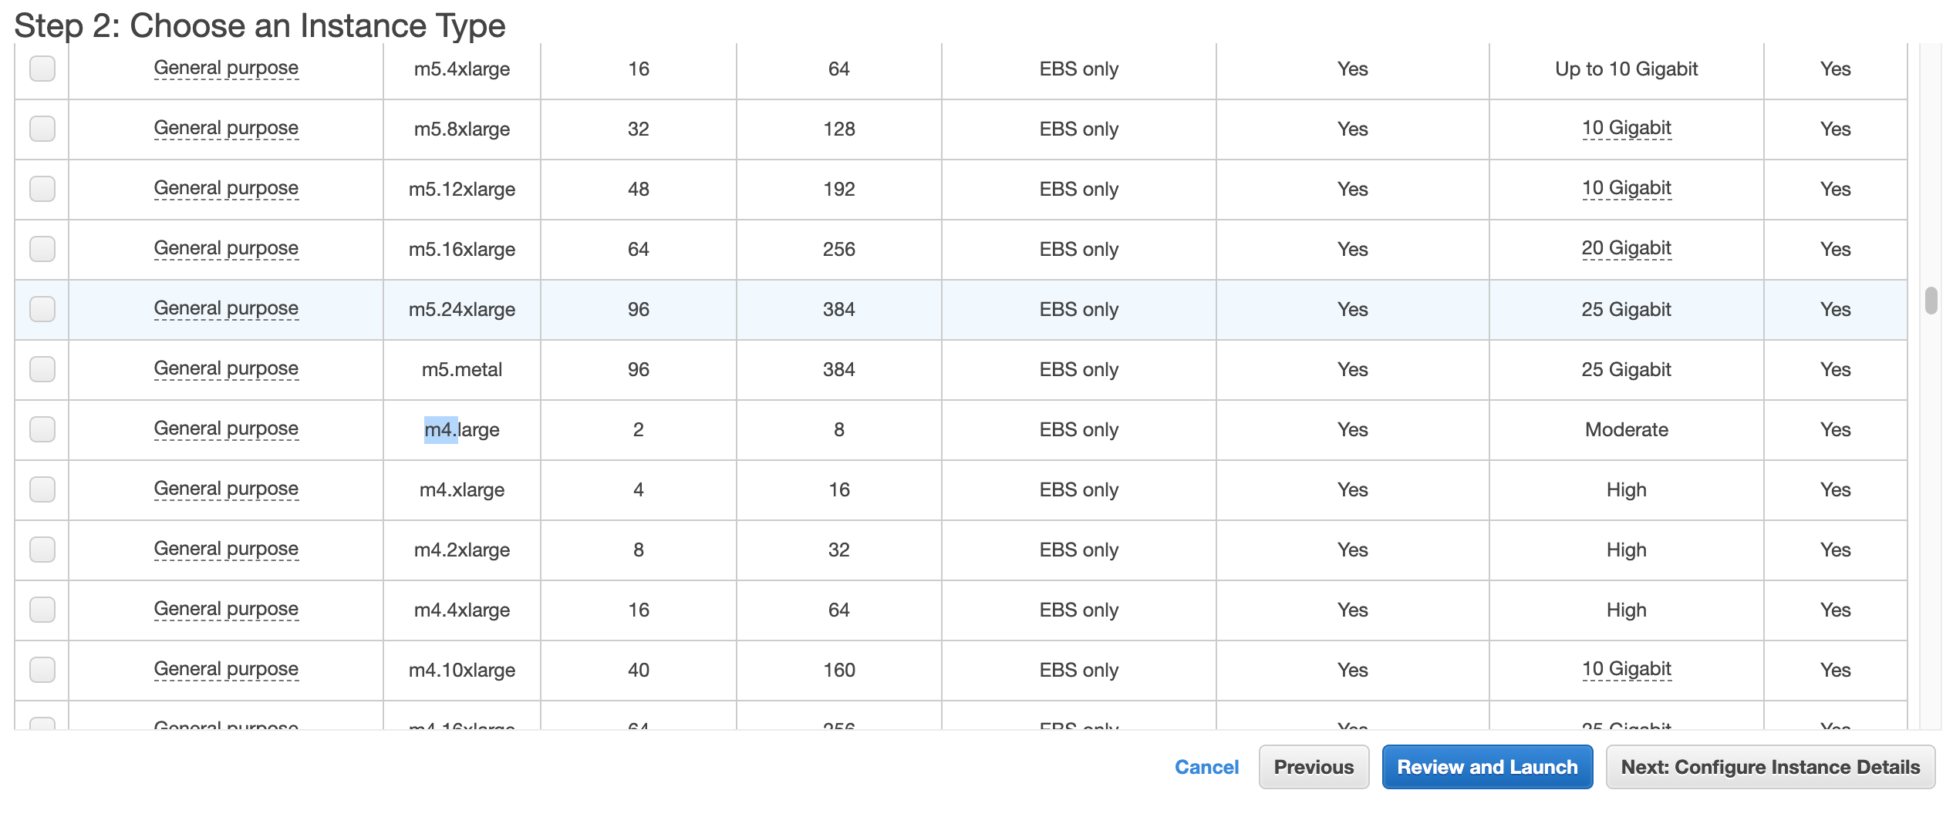

1. Select “Next: Configure Instance Details”



1. Select “Next: Add Storage”



1. Change the root storage size from 8 GiB to 30 GiB (if possible, otherwise as much as you can between 8 and 30 GiB). Then select “Review and Launch”



1. Now “Launch” the instance



1. Select an existing key pair (or create a new pair). You can use the same key pair you created for your EMR instances. Make sure to check the “I acknowledge…” checkbox.



1. You should see this. Select “View Instances”



1. Wait until the instance state is “running”. Note that the public address (Public DNS) is provided for use in connecting via ssh or scp to the instance.



1. Now you can ssh to the instance the easy way as follows.
   1. Make sure you check the EC2 instance
   2. Click on the “Connect” button.



c) Select the “SSH Client” tab



d) Cut and paste the example ssh command that appears into your terminal to connect to your instance



Note that in this case the user name of your account is “ubuntu” and the address of your instance <Public DNS (IPv4)> is also used. So the ssh command about is built as follows. Note <Public DNS (IPv4)> is replaced with the actual value listed in the previsouly shown instance information pane.

1. About terminal windows…

You will need to open up several terminal windows to set up and interact with Kafka. We will refer to these terminal windows by a unique name, which will, we hope, keep things clearer and more organized.

|  |  |  |
| --- | --- | --- |
| Terminal Window “Name” | Connected to… | Purpose |
| KT-1 | Local computer | Used to scp files from your local computer to the AWS virtual machine |
| KT-2 | AWS virtual machine using ssh | Used to execute the basic commands on the AWS virtual machine necessary to install, configure and start Kafka. Also, used to execute Kafka data producers. |
| KT-3 | AWS virtual machine using ssh | Used to execute Kafka data producers. |
| KT-4 | AWS virtual machine using ssh | Used to execute Kafka data consumers and output the data they consume. |

1. Now you can ssh to the EC2 instance as follows using the ssh command you just copied above:

ssh -i emr-key-pair.pem ubuntu@<Public DNS (IPv4)>

## Section 2: Installing basic software onto your EC2 instance

1. Download the Kafka software (kafka_2.12-2.3.0.tgz) from the assignment to your PC or MAC
2. In a terminal window (KT-1) “scp” the confluent Kafka software to your EC2 instance:

scp -i emr-key-pair.pem /path/to/ kafka_2.12-2.3.0.tgz ubuntu@<Public DNS (IPv4)>:/home/ubuntu

1. If you haven’t already done so, open a terminal window and “ssh” to your EC2 instance. We will call this window, now connected to the EC2 instance, the KT-2 terminal window

ssh -i emr-key-pair.pem ubuntu@<Public DNS (IPv4)>

1. Now into the EC2 console accessible through your “KT-2” terminal window enter the following commands one at a time. As each executes, they may ask you to respond with “Yes” or “Y”. Do so each time. On your instance console enter the following:
2. sudo apt update
3. sudo apt install zip
4. sudo apt install default-jre
5. sudo apt install default-jdk
6. sudo apt install python3-pip
7. pip3 install kafka-python
8. Then through your “KT-2” terminal window enter the following commands

tar -xvf kafka_2.12-2.3.0.tgz

1. Add the install location of the Kafka “bin” directory to your PATH in the KT-2 terminal window as follows:

export PATH=/home/ubuntu/kafka_2.12-2.3.0/bin:$PATH

Then change to the /home/ubuntu/kafka_2.12-2.3.0 directory:

cd /home/ubuntu/kafka_2.12-2.3.0

## Section 3: Starting Kafka

We need to have three windows connected to the EC2 instance for this section. If you have one already recall we refer to it as the “KT-2” terminal but we will need to open and connect two more windows to the EC2 instance.

1. Open a third terminal window and enter the following. We will refer to this as the “KT-3” terminal window.

ssh -i emr-key-pair.pem ubuntu@<Public DNS (IPv4)>

Add the install location of the Kafka “bin” directory to your PATH in the KT-3 terminal window as follows:

export PATH=/home/ubuntu/kafka_2.12-2.3.0/bin:$PATH

Then change to the /home/ubuntu/kafka_2.12-2.3.0 directory:

cd /home/ubuntu/kafka_2.12-2.3.0

1. Open a fourth terminal window and enter the following. We will refer to this as the “KT-4” terminal

ssh -i emr-key-pair.pem ubuntu@<Public DNS (IPv4)>

Add the install location of the Kafka “bin” directory to your PATH in the KT-1 window as follows:

export PATH=/home/ubuntu/kafka_2.12-2.3.0/bin:$PATH

Then change to the /home/ubuntu/kafka_2.12-2.3.0 directory:

cd /home/ubuntu/kafka_2.12-2.3.0

1. Kafka uses Zookeeper so you need to first start a local ZooKeeper server in the KT-2 terminal window. You use the following command packaged with kafka to get a quick-and-dirty single-node Zookeeper instance. Notice the “&” at the end of the command. It instructs the command shell to run this command in the background. This will allow you to enter further commands into the KT-2 window:

zookeeper-server-start.sh config/zookeeper.properties &

Note: you may need to press “Enter” a time or two for the Linux prompt to reappear.

1. Now start the Kafka server itself in the KT-2 terminal window as follows. Again, notice the “&” at the end of the command:

kafka-server-start.sh config/server.properties &

Note: you may need to press “Enter” a time or two for the Linux prompt to reappear.

## Section 4: Working with Kafka

1. Let's create a topic named "test" with a single partition and only one replica. Do so in the KT-3 terminal window:

kafka-topics.sh --create --bootstrap-server localhost:9092 --replication-factor 1 --partitions 1 --topic test

1. We can now see that topic if we run the list topic command in the KT-3 terminal window:

kafka-topics.sh --list --bootstrap-server localhost:9092

1. Kafka comes with a command line client that will take input from a file or standard input and send it out as messages to the Kafka cluster. By default, each line will be sent as a separate message. Run the producer in the KT-3 terminal window and then type a few messages into the console to send to the server:

kafka-console-producer.sh --broker-list localhost:9092 --topic test

Upon execution of this command you should see a prompt (“>”) in a few moments. When you see the prompt, enter two or three lines of text.

1. Kafka also has a command line consumer that will dump out messages to standard output. Run the consumer in the KT-4 terminal window as follows:

kafka-console-consumer.sh --bootstrap-server localhost:9092 --topic test --from-beginning

If you have each of the above commands running in a different terminal then you should now be able to see messages you previously typed in and also type new messages into the producer terminal and see them appear in the consumer terminal.

1. To end this part of the demo type control-c into the KT-3 terminal window and KT-4 terminal window to stop the producer and consumer. But keep the KT-3 terminal window and KT-4 terminal window connected to your kafka VM.
2. Writing data from the console and writing it back to the console is a convenient place to start, but you'll probably want to use data from other sources or export data from Kafka to other systems. For many systems, instead of writing custom integration code you can use Kafka Connect to import or export data. Kafka Connect is a tool included with Kafka that imports and exports data to Kafka. It is an extensible tool that runs *connectors*, which implement the custom logic for interacting with an external system. Here we will see how to run Kafka Connect with simple connectors that import data from a file to a Kafka topic and export data from a Kafka topic to a file.
3. Now, we'll start by quickly creating a file to test with using the KT-3 terminal window:

echo -e "foo\nbar" > test.txt

1. Next, we'll start two connectors running in standalone mode, using the following command below in the KT-3 window, which means they run in a single, local, dedicated process. We provide three configuration files as parameters. The first is always the configuration for the Kafka Connect process, containing common configuration such as the Kafka brokers to connect to and the serialization format for data. The remaining configuration files each specify a connector to create. These files include a unique connector name, the connector class to instantiate, and any other configuration required by the connect

connect-standalone.sh config/connect-standalone.properties config/connect-file-source.properties config/connect-file-sink.properties

These sample configuration files, included with Kafka, use the default local cluster configuration you started earlier and create two connectors: the first is a source connector that reads lines from an input file and produces each to a Kafka topic and the second is a sink connector that reads messages from a Kafka topic and produces each as a line in an output file.

During startup you'll see a number of log messages, including some indicating that the connectors are being instantiated. Once the Kafka Connect process has started, the source connector should start reading lines from test.txt and producing them to the topic connect-test, and the sink connector should start reading messages from the topic connect-test and write them to the file test.sink.txt. We can verify the data has been delivered through the entire pipeline by examining the contents of the output file entering the following command in the KT-4 window

more test.sink.txt

And you should see the following:

foo

bar

Now type control-c into the KT-4 terminal window to stop the “more”

1. Note that the data is being stored in the Kafka topic connect-test, so we can also run the following console consumer command in the KT-4 terminal window to see the data in the topic (or use custom consumer code to process it):

kafka-console-consumer.sh --bootstrap-server localhost:9092 --topic connect-test --from-beginning

And you should see the following:

{"schema":{"type":"string","optional":false},"payload":"foo"}

{"schema":{"type":"string","optional":false},"payload":"bar"}

Now type control-c into the KT-4 window to stop the consumer.

1. The connectors continue to process data, so we can add data to the file and see it move through the pipeline. Enter the following into the KT-3 terminal window

echo Another line>> test.txt

You should see the line appear in the console consumer output and in the sink file if you then do the following:

more test.sink.txt

And you should see the following:

foo

bar

Another line

## Section 5: Managing your EC2 instance

Your instance:

* Some basic facts about managing your instance. If you stop the instance you do not lose any of the software you installed but you will lose all topics and their contents. You will also stop the execution of zookeeper, kafka and any connectors and other related processes. So, when you start the EC2 instance again, you will need to restart these processes and redefine any topics.
* When you terminate the instance you completely lose everything, including the software you installed.
* When you (re)start an instance it will get a new public DNS address, so make sure to find out what it is.

To manage an EC2 instance

1. Click on the actions button
2. Click “View Details”



Then select the “Actions” button and a list of actions will be displayed. Now select “Stop instance” “Start instance” or “Terminate instance” as required.

